Phase I and Phase II Results – (MA)

A. Plots of Predictors vs. HPI (simple returns)

Original HPI Series

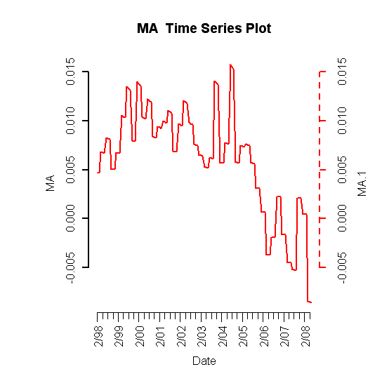
Building Permits
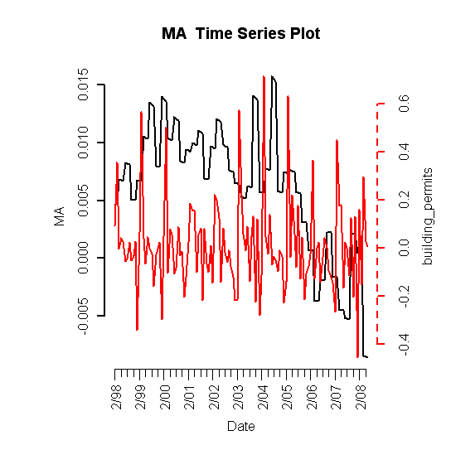
Foreclosures
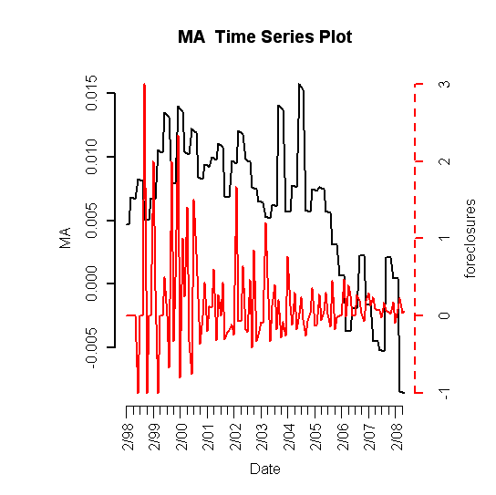

Population Size
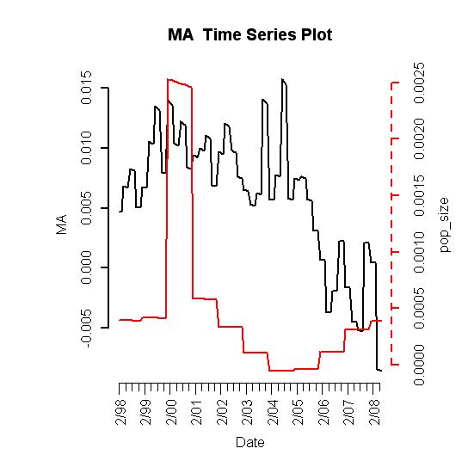
Unemployment Rate
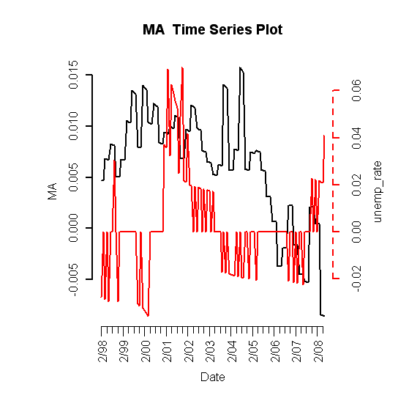
Mortgage Originations

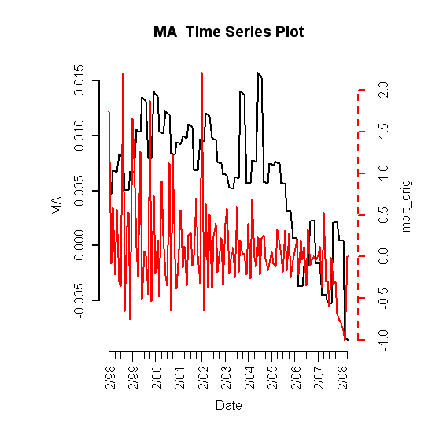

30-Year Commitment Rate
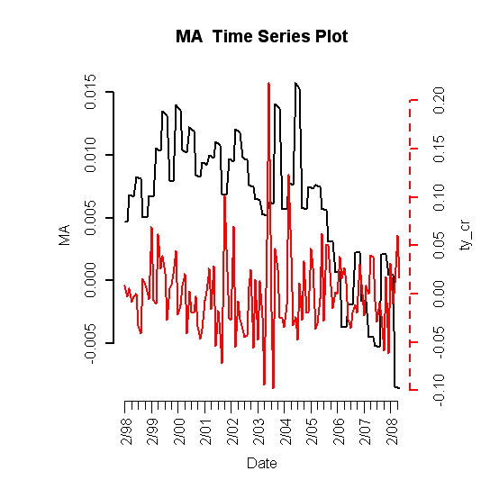

Median Income
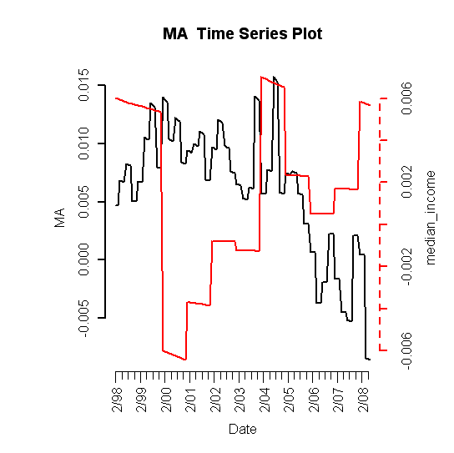

B. Plot of Lagged Predictors vs. HPI (simple returns)

*Non-lagged predictors are not shown

Building Permits (lag 5)
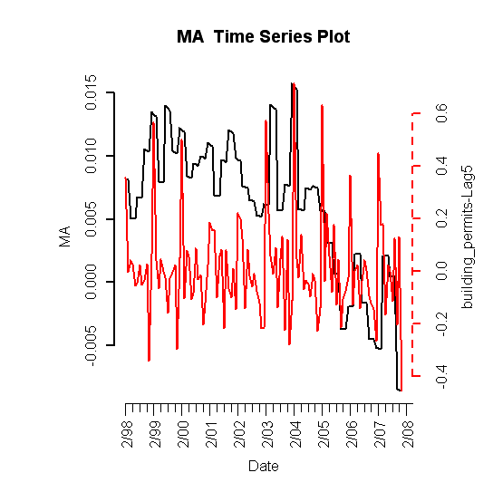

Foreclosures (lag 4)
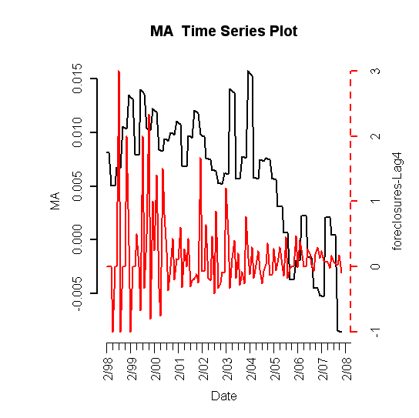
Mortgage Originate (lag 4)
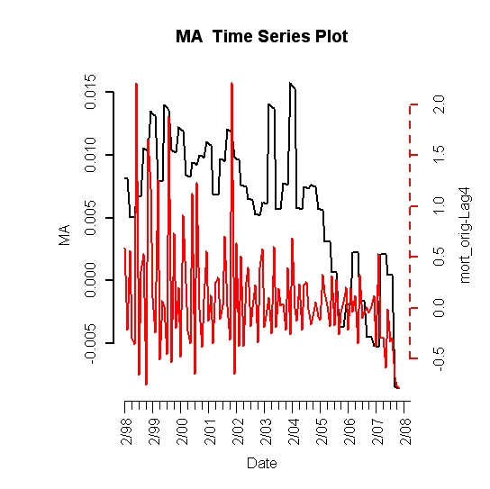

Population Size (lag 6)
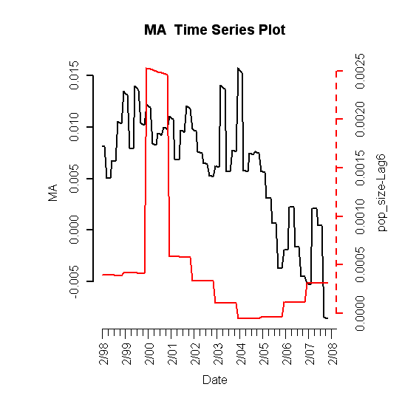

C. Scatterplots (simple return)

HPI vs. HPI
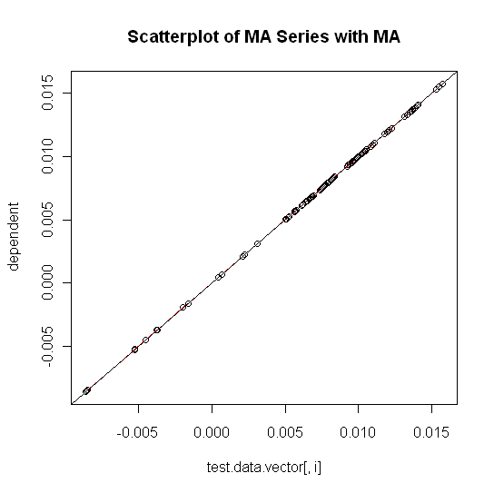

HPI vs. Building Permits
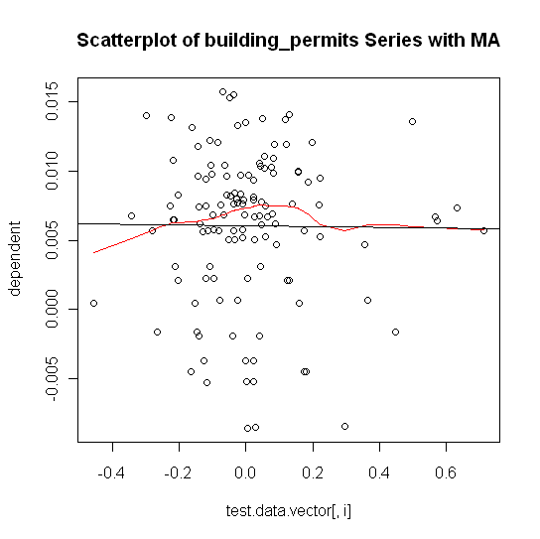

HPI vs. Foreclosures
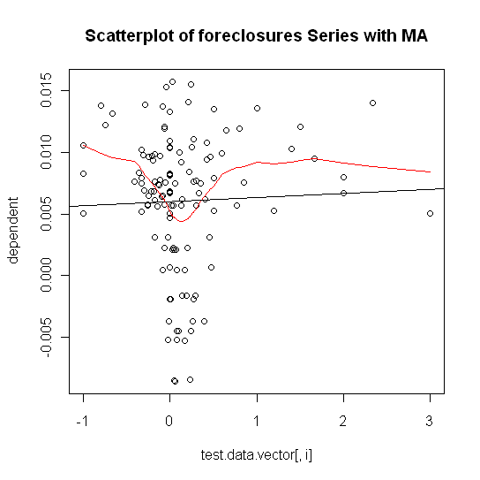

HPI vs. Population Size
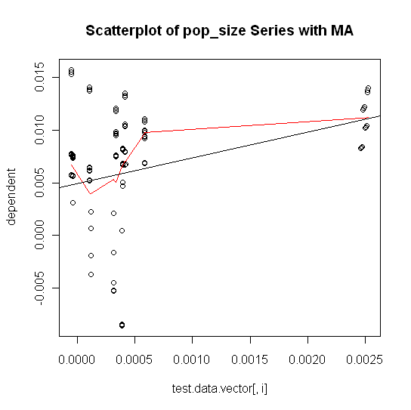

HPI vs. Unemployment Rate
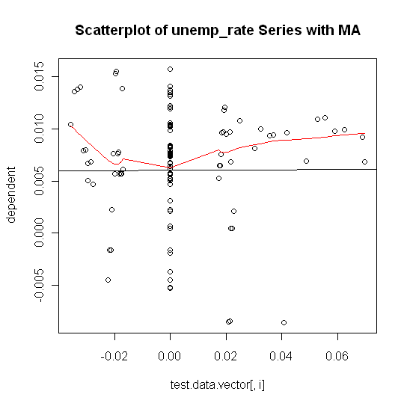

HPI vs. Mortgage Originations
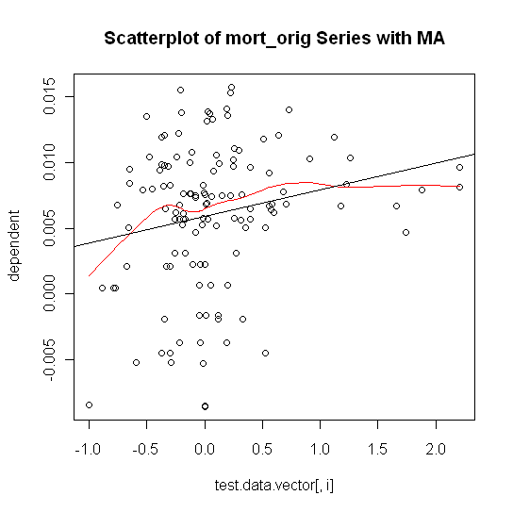

HPI vs. 30-Year Commitment Rate
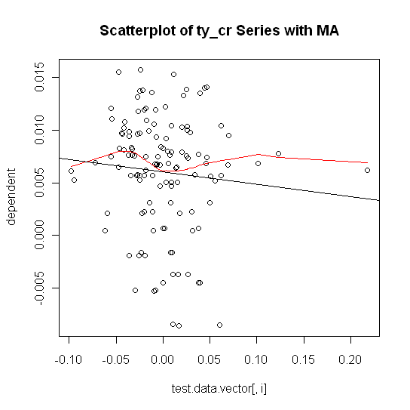

HPI vs. Median Income
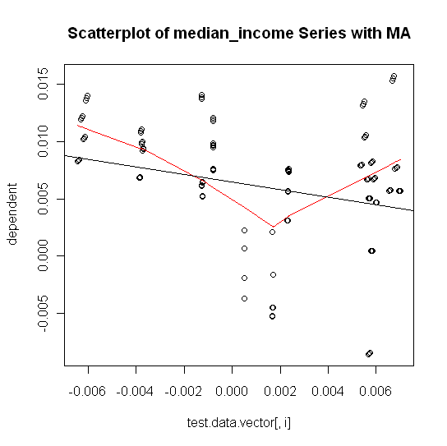

C. Exhaustive Stepwise Regression

D. Final RLM Model

Robust Linear Model (significant predictors only)

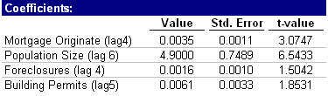

Fitted HPI vs. Actual HPI (without residuals)
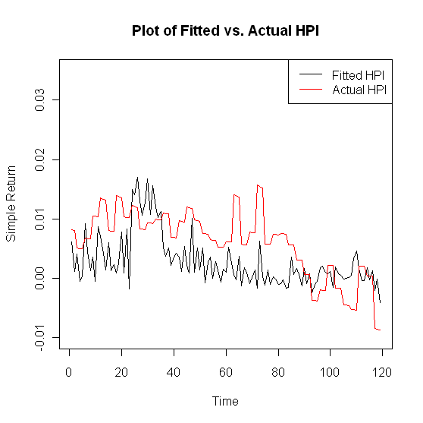

1. Phase I

ACF of Residuals
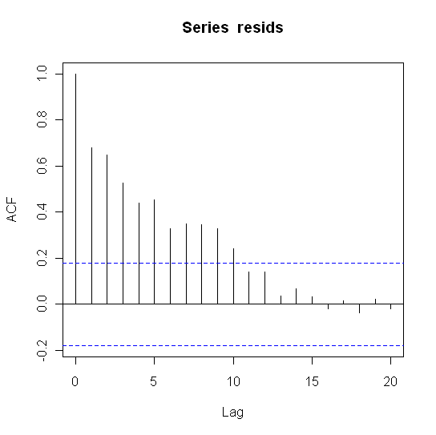
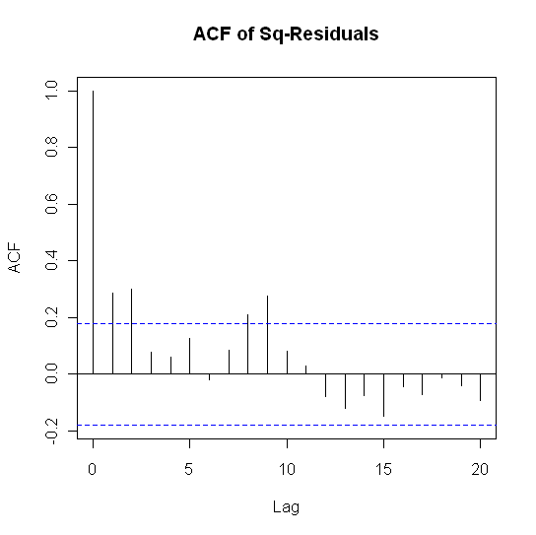

PACF and ADF Test
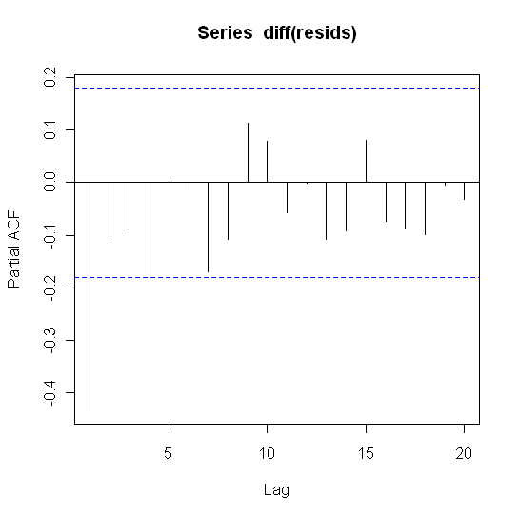
The value of the test statistic is: -2.234274

1pct 5pct 10pct
tau1 -2.58 -1.95 -1.62

Box-Ljung Test

data: resids
X-squared = 258.783, df = 12, p-value < 2.2e-16

2. Phase II

Estimates:
 | Value | Std. Error
ar1 | 9.01E-01 | 5.25E-02
ma1 | -0.4356 | 0.1072
Intercept | 2.60E-03 | 1.90E-03

> Box.Ljung.test(arima.fit$resid,lag = 12, adj.DF = 12-params)
Box-Ljung test
data: data
X-squared = 8.6923, df = 10, p-value = 0.5615

> Box.Ljung.test(arima.fit$resid^2,lag = 12, adj.DF = 12)
Box-Ljung test
data: data
X-squared = 13.0951, df = 12, p-value = 0.3622

Fitted HPI vs. Actual HPI (with modeled residuals)
